**Part 2**

Q3. Part A

Steps to perform Marr-Hildreth edge detection:

1. Apply Gaussian filter to smooth the image
2. Apply Laplacian to detect edges
3. Detect zero-crossings by checking sign changes
4. keep only strong edges: |g(x + 1,y) − g(x −1,y)|> threshold
5. Those positions follows step 3 & 4, make their intensity 255 else 0.

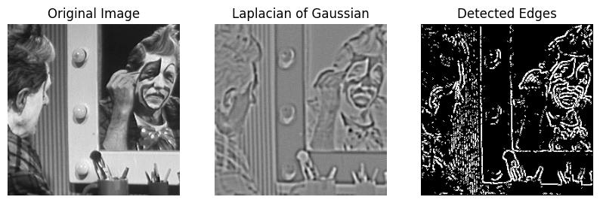

Parameters used:

σ = 2

Laplacian kernel size = 3

Threshold = 15 (only strong edges detected)

Q3. Part B  
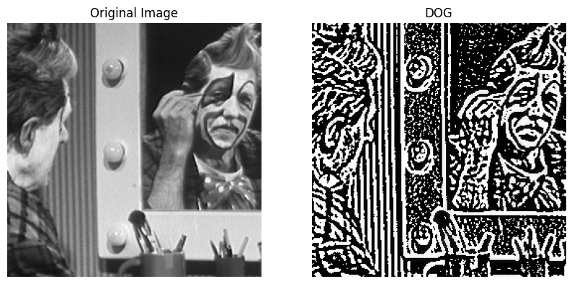

σ = σ for LOG  
 & for DOG ( = 1.6 )

Q3. Part C

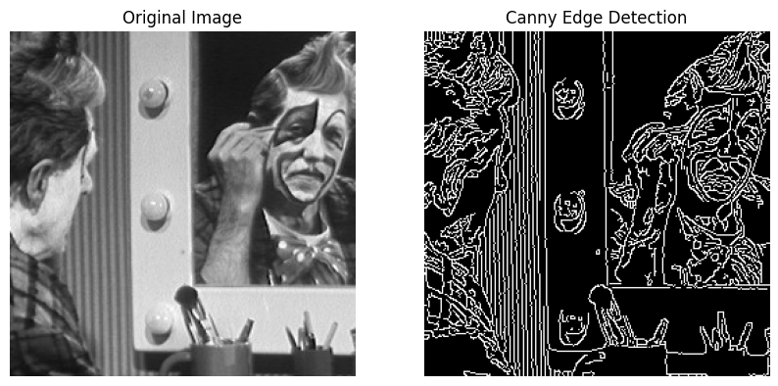

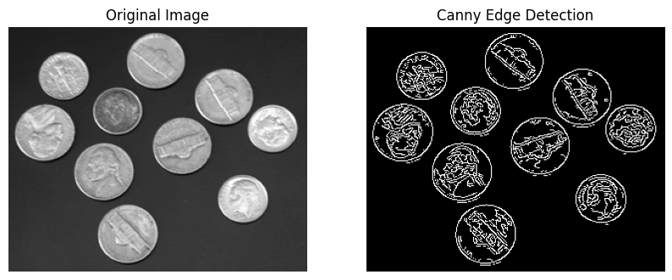

Low threshold = 50 and High threshold = 150

Q3. Part D  
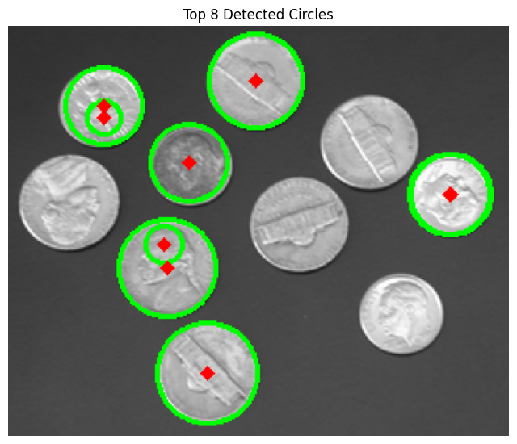

Q4. Part A

**Otsu's Method:**

Threshold = 42,

Within-Class Variance = 397.10443971363355,

Between-Class Variance = 693.8300285196959

**k-Means Method:**

Threshold = 43,

Mean1 = 15.044552826597554,

Mean2 = 71.5253290678386,

Within-Class Variance = 397.1170367677733,

Between-Class Variance = 693.8174314655562

Q4 Part B

Here, K = 3

There is very less variability in between-class-variance and visual outputs. This indicating less sensitivity to initialization.

Q4. Part C  
  
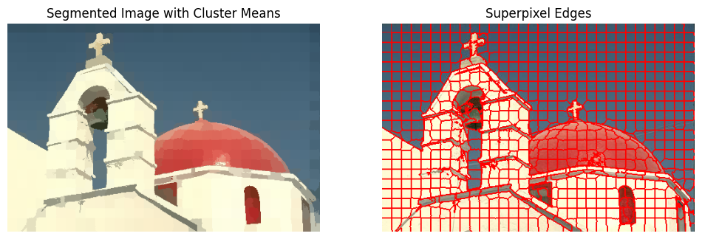

S = 15